Learning Objectives
  - Different Range Sensors
  - Importance of range sensors
  - comparison of different range sensors

Range Sensor
A range sensor is a type of sensor that provides information about the distance between the sensor and an object or surface in its environment. Range sensors are used in robotics and other fields to enable machines to navigate, avoid obstacles, and interact with their surroundings.
There are several types of range sensors, including:
- Ultrasonic sensors:
An ultrasonic sensor is a device that uses sound waves with high frequencies (usually between 20 kHz and 200 kHz) above the range of human hearing to figure out how far away things are. It works by sending out a sound wave and timing how long it takes for the wave to return after hitting something.
The HC-SR04 is a type of ultrasonic sensor that is often used in robotics and automation projects. It has two main parts: an ultrasonic transmitter and a receiver for ultrasonic waves. The transmitter sends out a high-frequency sound wave, which bounces off anything in its way and comes back to the receiver. The receiver counts how long it takes for the sound wave to come back and uses the speed of sound in air to figure out how far away it is.
The HC-SR04 ultrasonic sensor works like this:
1. The sensor's transmitter sends out a pulse of sound waves.
2. The sound waves move through the air and hit things in their way.
3. The sound waves that were sent back to the sensor come back to the receiver.
4. The sensor measures how long the sound waves take to come back.
5. The sensor figures out how far away the object is based on how long it takes for the sound waves to come back.

Robots often use ultrasonic sensors like the HC-SR04 to avoid obstacles, measure distance, and find their way. They can also be used to automate factories, make parking sensors for cars, and make medical devices.
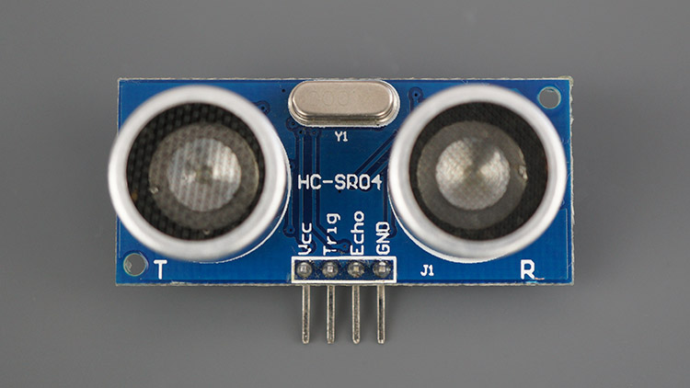
- Laser rangefinders:
Laser rangefinders are devices that accurately measure the distance between two points by using laser technology. They send out a laser beam, which is picked up by the rangefinder after it bounces off the target. The speed of light is used to figure out how far away the target is based on how long it takes the laser to get there and back.
Laser rangefinders are used in many different areas, such as surveying, building, golfing, hunting, and the military. They are especially helpful when it is important to measure distances accurately, like when playing golf and trying to figure out how far away the pin is or when building a building and trying to figure out how tall it is.
The Leica Rangemaster CRF 2800.COM is a type of laser rangefinder. It's a small rangefinder that works well and is popular with hunters and long-range shooters. The Rangemaster CRF 2800.COM can quickly and accurately measure distances using a Class 1 Eye Safe laser.
The Leica Rangemaster CRF 2800.COM works like this:
A laser beam comes out of the rangefinder and heads toward the target.
2. The target makes the laser beam bounce back to the rangefinder.
3. The rangefinder keeps track of how long it takes for the laser beam to get to and from the target.
4. The rangefinder figures out how far away the target is based on how long it takes to measure time.
The Leica Rangemaster CRF 2800.COM has a range of up to 2,800 yards and built-in Bluetooth connectivity that lets it connect to a smartphone app where it can store ballistic data and give customized aiming solutions. It is also small and light, so it is easy to move around with.
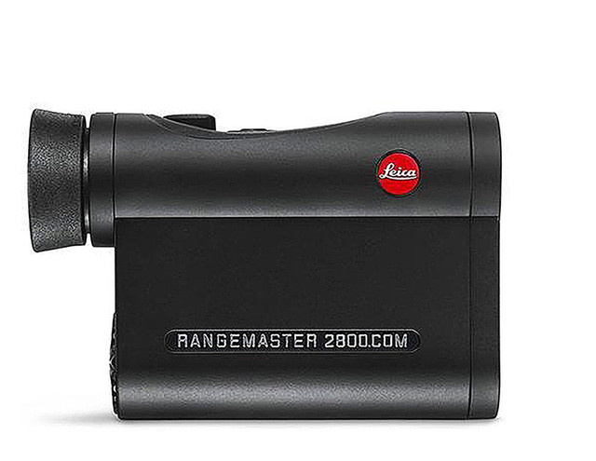
- Time-of-flight sensors:
Time-of-flight sensors are pieces of equipment that use light to figure out how far apart things are in their field of view. They work by sending out a pulse of light and measuring how long it takes for the light to reach the object and come back. Based on this measurement of time, the sensor can figure out how far away the object is from the sensor.
Time-of-flight sensors are used in robotics, virtual and augmented reality, and safety systems for cars, among other things. They are especially useful in self-driving cars and drones, where depth perception is important.
The VL53L0X is a small laser-ranging module that uses a pulsed laser to measure distances very accurately. It is an example of a time-of-flight (ToF) sensor. The VL53L0X is often used in robots, drones, and other systems that need to measure distance.
The VL53L0X ToF sensor works like this:
1. A laser pulse is sent out by the sensor.
2. An object in the laser's field of view reflects the laser pulse.
3. The sensor picks up the pulse that was sent back and measures how long it takes to come back.
4. The sensor figures out how far away the object is based on how long it takes to measure time.
The VL53L0X ToF sensor can measure distances with an accuracy of +/- 3% over a range of up to 2 meters. It also has a programmable region of interest (ROI) that lets you set up your own detection zones and supports a number of communication interfaces like I2C and SPI.
The Kinect sensor is another example of a ToF sensor. It was originally made for the Xbox gaming system, but it has since been used in many different ways. The Kinect sensor makes a 3D map of its surroundings by using both infrared light and Time of Flight (ToF) technology. It can be used to recognize gestures, scan in 3D, and even help robots and cars drive themselves.
More Details: https://www.seeedstudio.com/blog/2020/01/08/what-is-a-time-of-flight-sensor-and-how-does-a-tof-sensor-work
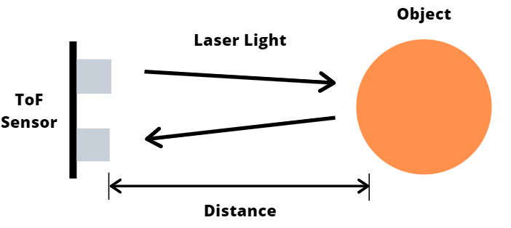
- Infrared sensors:
Infrared (IR) sensors are electronic devices that can detect and measure IR radiation. They are used for many things, like measuring temperature, detecting motion, and measuring distance. Here are some examples of where IR sensors are used:
1. PIR sensors: Passive infrared (PIR) sensors are used in security systems, lighting control systems, and automatic doors to detect when someone is moving. They pick up the heat that living things give off and set off an alarm or turn on a device when they sense motion. The HC-SR501 is an example of a PIR sensor. It is a low-cost module that is often used for motion sensing.
2. Infrared thermometers: These are used in industrial and medical settings to measure temperatures without having to touch them. They measure how much IR radiation an object gives off and use that information to figure out how hot it is. The Fluke 62 Max is an example of an infrared thermometer. It is tough and reliable, and it can measure temperatures from -30°C to 500°C.
3. Proximity sensors: Proximity sensors are used in industry and cars to find objects and measure their distance. They measure how far away an object is based on how long it takes IR radiation to travel from the object to the sensor and back. The Sharp GP2Y0A41SK0F is an example of an IR proximity sensor. It is a small, low-cost module that can measure distances from 4cm to 30cm.

4. IR receivers: These are used to control consumer electronics like TVs, DVD players, and air conditioners with remote controls. They pick up the IR radiation that a remote control sends out and decode the signal to do a certain job. The TSOP4838 is a module that is often used with remote controls and is an example of an IR receiver.
These are just a few examples of IR sensors and what they can be used for. IR sensors can be used in many different industries and fields.
More Details: https://www.circuits-diy.com/ir-sensor-module-circuit/
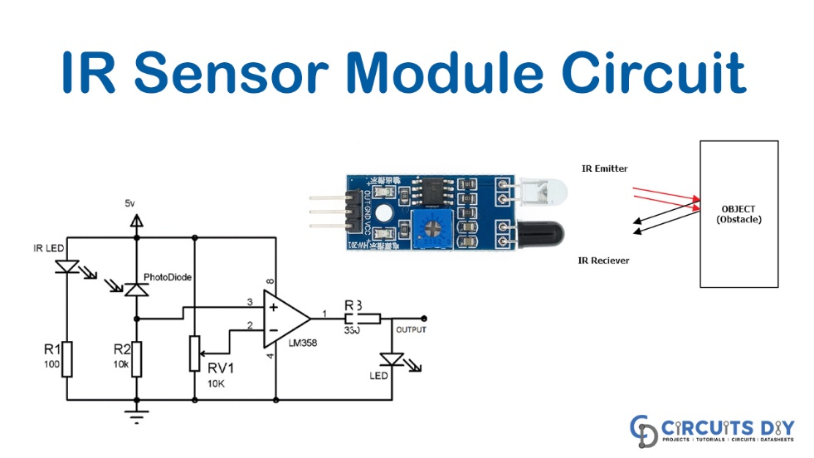
Range sensors are important for enabling robots to operate autonomously and navigate their environment safely and efficiently. By providing accurate distance information, range sensors allow robots to avoid obstacles, follow paths, and interact with their environment in a precise and controlled manner.
Importance of range sensors in robotics
Range sensors play a crucial role in robotics by providing robots with the ability to perceive and interact with their environment. Without range sensors, robots would be unable to navigate their surroundings safely and efficiently, as they would lack the ability to detect and avoid obstacles, accurately locate objects, or measure distances.
For instance, in industrial automation, range sensors are used to detect objects in a factory environment to ensure that robots can avoid collisions and operate safely. In autonomous vehicles, range sensors such as lidar are used to detect and map the environment to enable safe and reliable navigation. Similarly, range sensors are used in drones to enable obstacle avoidance and precision landing.
Range sensors also play an important role in robot-human interaction, such as in medical robotics, where range sensors are used to enable robots to safely interact with patients and healthcare professionals. Additionally, in search and rescue missions, robots with range sensors can locate and extract victims from hazardous environments, such as collapsed buildings or natural disasters.
Overall, range sensors are critical for enabling robots to perceive and interact with their environment and are essential for a wide range of applications in robotics.
Comparison of Range Sensors
Range sensors vary in their working principles, accuracy, range, resolution, cost, power consumption, size and weight, and environmental factors. Here is a comparison of the most common types of range sensors used in robotics:
 | Ultrasonic Sensors | Laser Rangefinders | Time-of-Flight Sensors | Infrared Sensors
Working Principle | Emit high-frequency sound waves and measure the time it takes for the sound waves to bounce back from an object to calculate distance. | Emit laser beams and measure the time it takes for the laser beams to bounce back from an object to calculate distance. | Emit a pulse of light and measure the time it takes for the light to bounce back from an object to calculate distance. | Emit infrared light and measure the amount of light reflected from an object to calculate distance.
Accuracy | Moderate | High | High | Low to moderate
Range | Up to several meters | Up to hundreds of meters | Up to tens of meters | Up to several meters
Resolution | Moderate | High | High | Low to moderate
Cost | Low | High | Moderate to high | Low to moderate
Power Consumption | Low | High | Moderate | Low
Size and Weight | Small and lightweight | Large and heavy | Small to moderate | Small and lightweight
Environmental Factors | Sensitive to air temperature and humidity | Sensitive to weather conditions such as rain, snow, and fog | Sensitive to ambient light and reflective surfaces | Sensitive to ambient light and reflective surfaces

